Hadoop Cluster Installation
Created a 3 Linux VM machines in AWS with t2. large which has following resources:
Master node – 2 VCPU,8 GB RAM
Data node 1 – 2 VCPU,8 GB RAM
Data node2– 2 VCPU,8 GB RAM
While launching instances use the following script:

Setup Prerequisites on Master Node:

1)Install Centos

2) add the hostname and ip address of all nodes to /etc/hosts

3)Create Hadoop user and add to Hadoop group

groupadd hadoop

useradd -g hadoop hduser

4)Switch to Hadoop user and configure passwordless ssh between datanodes
https://www.itzgeek.com/how-tos/linux/centos-how-tos/ssh-passwordless-login-centos-7-rhel-7.html

su – hduser

ssh-keygen -t rsa

5)NOW DOWNLOAD THE CLOUDERA-MANAGER.BIN FILE USING THE FOLLOWING LINK

$wget http://archive.cloudera.com/cm5/installer/5.10.1/cloudera-manager-installer.bin

6)Install repo as tarball based on your RHEL version $wget http://archive.cloudera.com/cm5/repo-as-tarball/5.10.1/cm5.10.1-centos7.tar.gz

7)Extract the tar file and copy the file to web server repository. tar zxvf cm5.10.1-centos7.tar.gz -C /var/www/html/

8)Configure yum to use local repository Go to cd /etc/yum.repos.d/ #Create file and add following lines

- cloudera-manager.repo [cloudera-manager] name=cloudera-manager baseurl=http://192.168.50.8/cm/5.10.1/ gpgcheck=1 gpgfile=http://192.168.50.8/cm/RPM-GPG-KEY-cloudera :wq

yum repolist

9)NOW SET THE PERMISSIONS TO THE ABOVE FILE TO MAKE IT EXECUTABLE AS THE FOLLOWING

$chmod u+x cloudera-manager-installer.bin

10)NOW SET THE PERMISSIONS TO THE ABOVE FILE TO MAKE IT EXECUTABLE AS THE FOLLOWING

$chmod u+x cloudera-manager-installer.bin
11)Execute or run the Cloudera installer bin file

$ ./cloudera-manager-installer.bin - - skip_repo_package=1

- Accept the license and it starts downloading oracle-jdk, Cloudera manage server, Cloudera manager client, embedded database.
- Point your web browser to http://192.168.50.8:7180/ where ip address is name node ip and port number 7180 is Cloudera manager port.
- Login to Cloudera Manager with username: admin and password: admin then press login
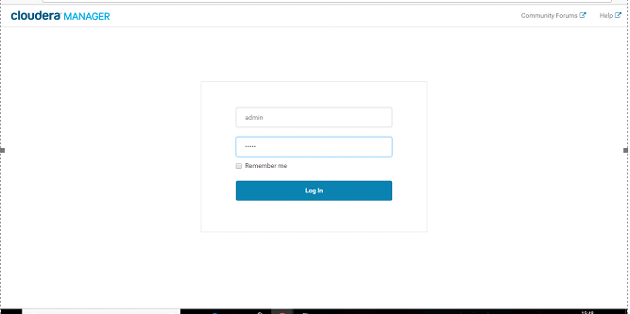

- After Logging in, you will see the welcome screen as below.
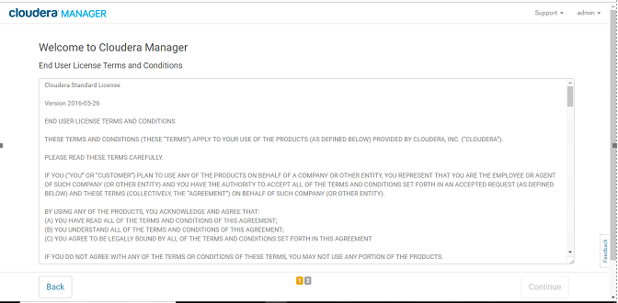
- Accept the license and press continue.
- Here selects the Cloudera feature by requirement,
  - Cloudera express is a full-time free version
  - Cloudera enterprise trial will give a one-month trial for this edition
  - Cloudera enterprise is a full-time paid version
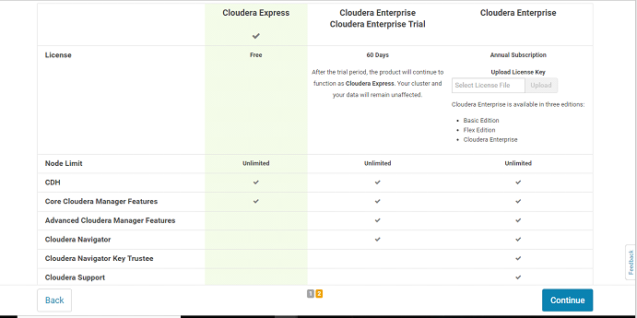
- Press continue again and again until this page appears where we need to enter ip address of your nodes (name node and data nodes) and enter search to ping those nodes.
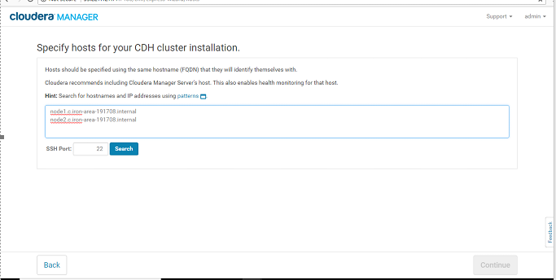
- To find the hostname and ip address of the machines enter
hostname -f
11)Once all nodes are reachable with ping then press continue.
12) Now select parcels(recommended) method if you are new to Cloudera installation. Then Select the latest version here.
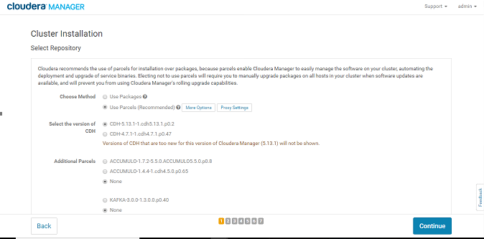
13) Then select remaining Additional parcels as none. Now select the matched release for Cloudera manager at last.
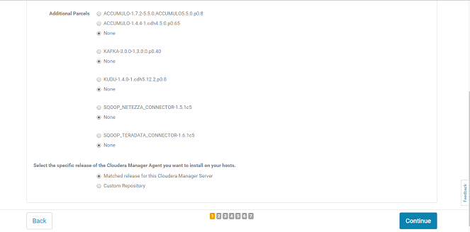
14)Press continue on next page. Then select JDK check box and select encryption policy check box if install Kerberos later on your nodes then select continue on other pages.
15)Then installation will go on and after successful installation press continue.
16) Then parcels will be installed on next page as follows:
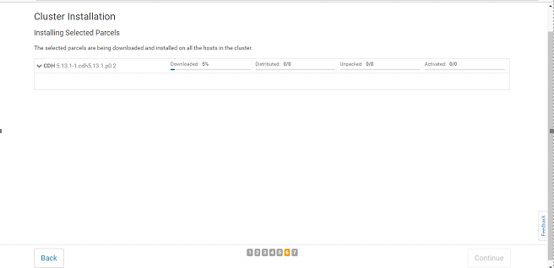17) Now you can see the green ticks if the installation was successful. If you find orange or red symbols there, check the issue in the nodes and do the installation again.
Setup Prerequisites on Data Node 1:

- Hostname -f (copy host name and use in step 2)
- Add the hostname and ip address of all nodes to /etc/hosts file.

- Configure password less SSH between all hosts.

Setup Prerequisites on Data Node 2:

- Hostname -f (copy host name and use in step 2)
- Add the hostname and ip address of all nodes to /etc/hosts file.

- Configure password less SSH between all hosts

